**Отчёт по выполнению**   
Разработка, администрирование и защита баз данных

# Реализация разработанной БД в MSSQL отредактировала данные в таблицах excel, исправила дату\число, типы данных. Привела таблицы в 2-3 нормальной форме, для хранения связи многим-ко-многим создала 2 таблицы и перенесла туда данные.

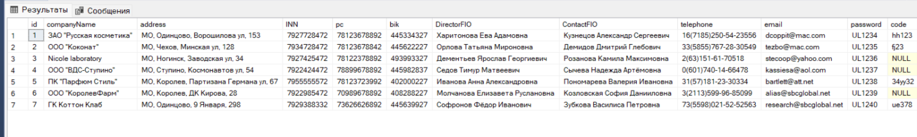

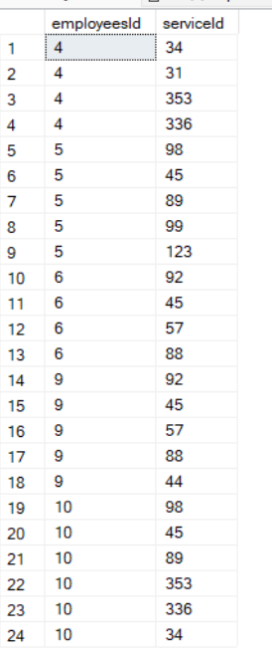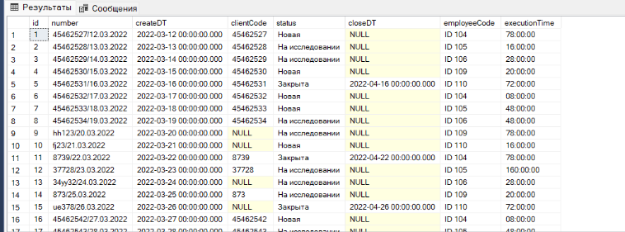

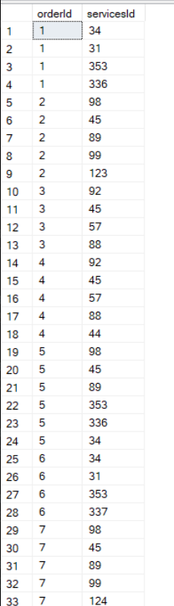

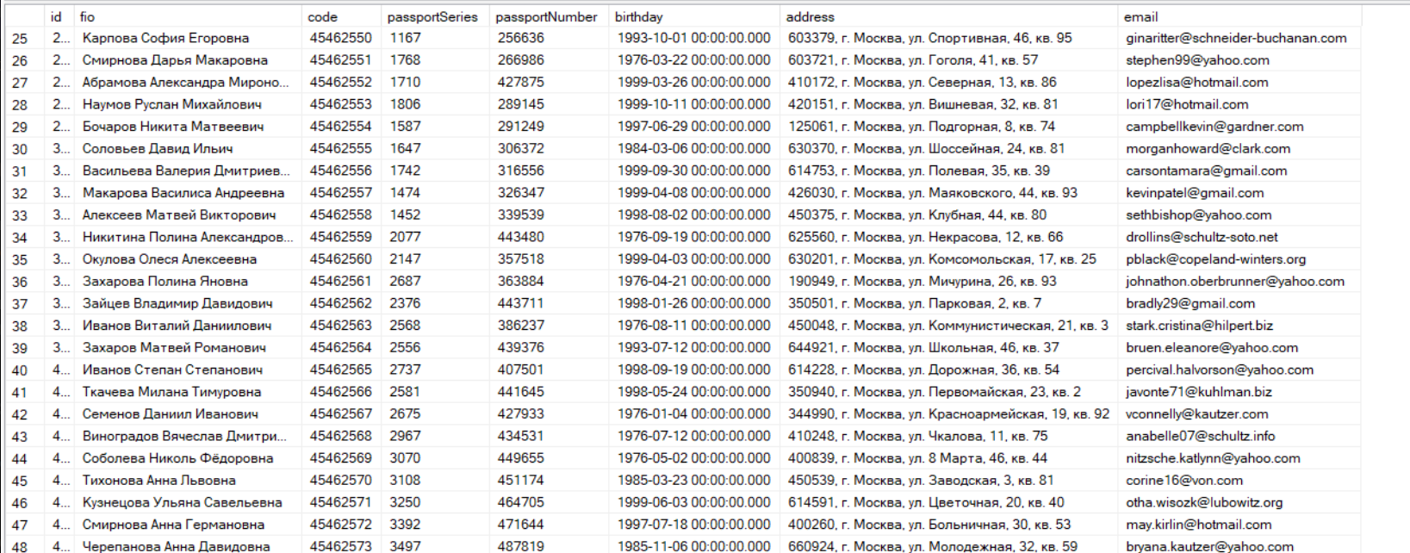

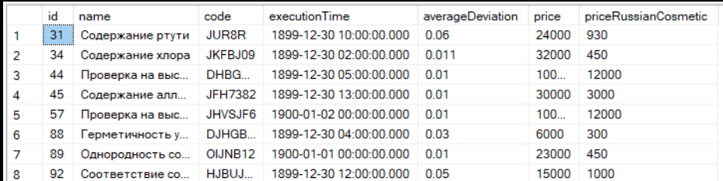

# Сохранение данных и результатов Как я поняла необходимо созданные таблицы с помощью импорта экспортировать в SQL скрипт.

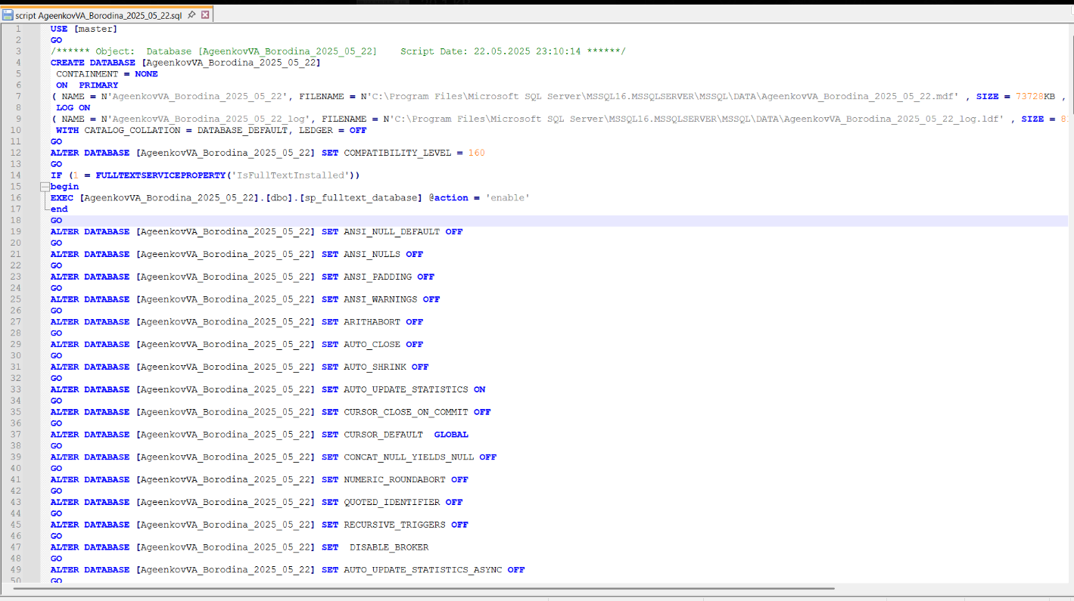

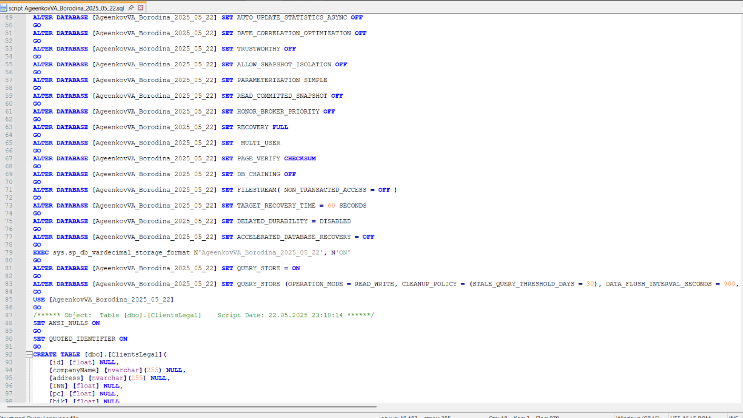

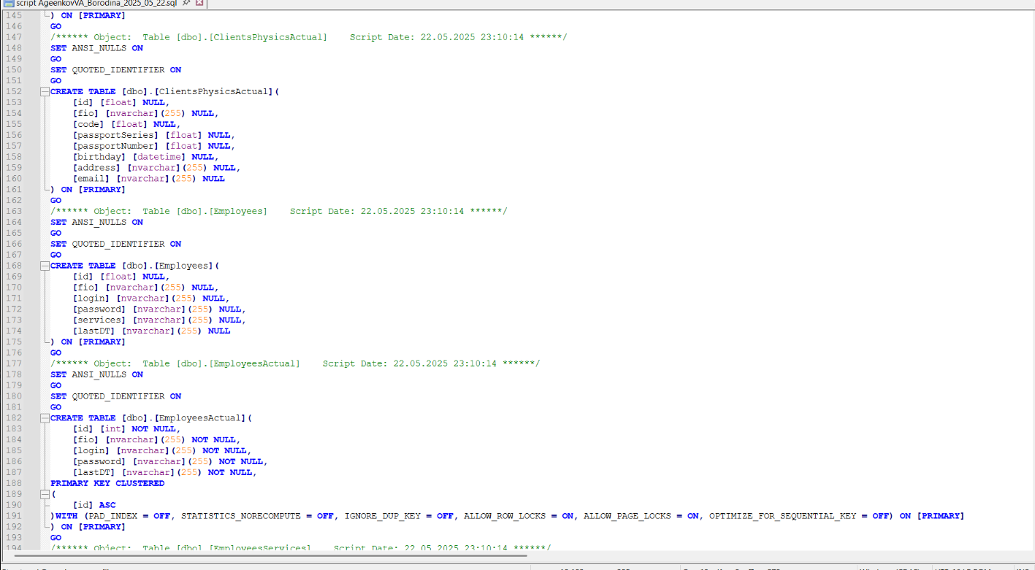

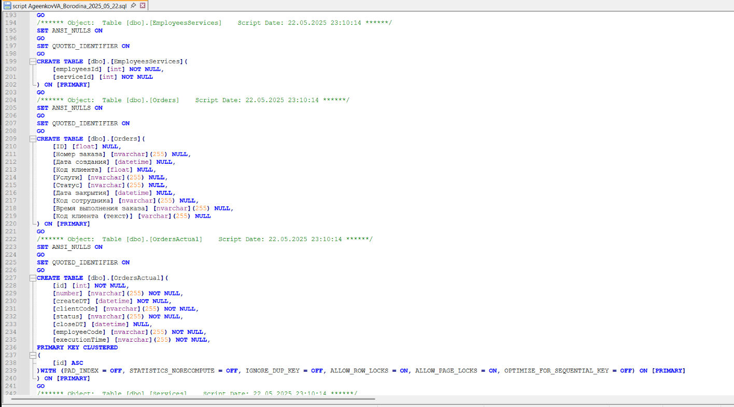

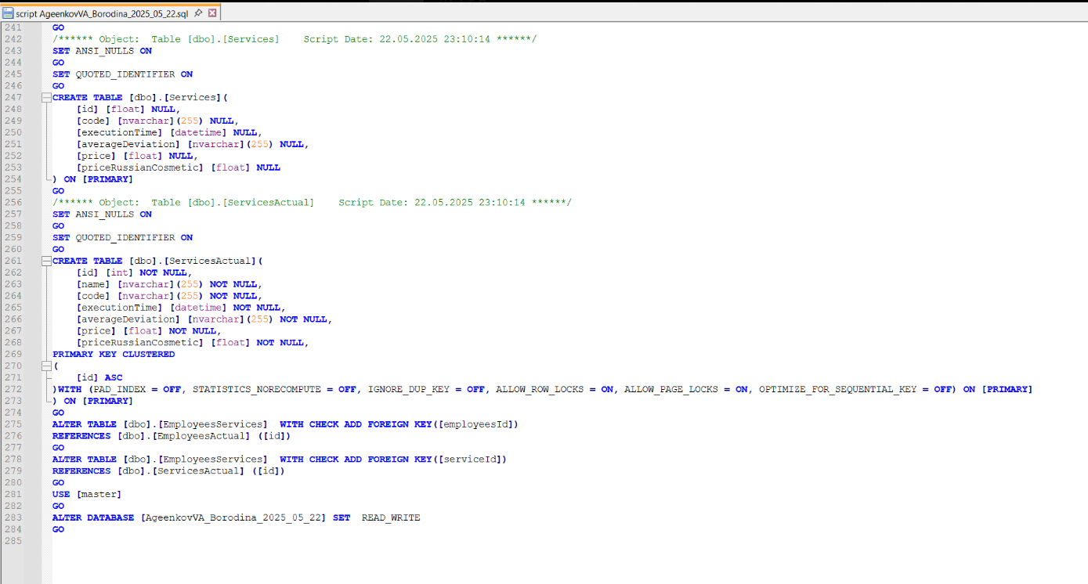

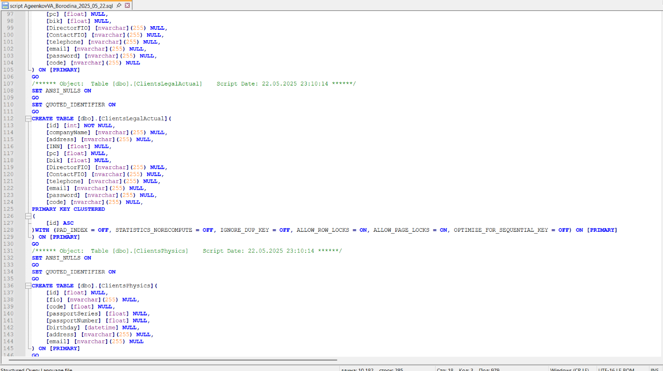

**КОД (ЕСЛИ НЕУДОБНО СКРИНШОТАМИ)**

USE [master]

GO

/****** Object: Database [AgeenkovVA_Borodina_2025_05_22] Script Date: 22.05.2025 23:10:14 ******/

CREATE DATABASE [AgeenkovVA_Borodina_2025_05_22]

CONTAINMENT = NONE

ON PRIMARY

( NAME = N'AgeenkovVA_Borodina_2025_05_22', FILENAME = N'C:\Program Files\Microsoft SQL Server\MSSQL16.MSSQLSERVER\MSSQL\DATA\AgeenkovVA_Borodina_2025_05_22.mdf' , SIZE = 73728KB , MAXSIZE = UNLIMITED, FILEGROWTH = 65536KB )

LOG ON

( NAME = N'AgeenkovVA_Borodina_2025_05_22_log', FILENAME = N'C:\Program Files\Microsoft SQL Server\MSSQL16.MSSQLSERVER\MSSQL\DATA\AgeenkovVA_Borodina_2025_05_22_log.ldf' , SIZE = 8192KB , MAXSIZE = 2048GB , FILEGROWTH = 65536KB )

WITH CATALOG_COLLATION = DATABASE_DEFAULT, LEDGER = OFF

GO

ALTER DATABASE [AgeenkovVA_Borodina_2025_05_22] SET COMPATIBILITY_LEVEL = 160

GO

IF (1 = FULLTEXTSERVICEPROPERTY('IsFullTextInstalled'))

begin

EXEC [AgeenkovVA_Borodina_2025_05_22].[dbo].[sp_fulltext_database] @action = 'enable'

end

GO

ALTER DATABASE [AgeenkovVA_Borodina_2025_05_22] SET ANSI_NULL_DEFAULT OFF

GO

ALTER DATABASE [AgeenkovVA_Borodina_2025_05_22] SET ANSI_NULLS OFF

GO

ALTER DATABASE [AgeenkovVA_Borodina_2025_05_22] SET ANSI_PADDING OFF

GO

ALTER DATABASE [AgeenkovVA_Borodina_2025_05_22] SET ANSI_WARNINGS OFF

GO

ALTER DATABASE [AgeenkovVA_Borodina_2025_05_22] SET ARITHABORT OFF

GO

ALTER DATABASE [AgeenkovVA_Borodina_2025_05_22] SET AUTO_CLOSE OFF

GO

ALTER DATABASE [AgeenkovVA_Borodina_2025_05_22] SET AUTO_SHRINK OFF

GO

ALTER DATABASE [AgeenkovVA_Borodina_2025_05_22] SET AUTO_UPDATE_STATISTICS ON

GO

ALTER DATABASE [AgeenkovVA_Borodina_2025_05_22] SET CURSOR_CLOSE_ON_COMMIT OFF

GO

ALTER DATABASE [AgeenkovVA_Borodina_2025_05_22] SET CURSOR_DEFAULT GLOBAL

GO

ALTER DATABASE [AgeenkovVA_Borodina_2025_05_22] SET CONCAT_NULL_YIELDS_NULL OFF

GO

ALTER DATABASE [AgeenkovVA_Borodina_2025_05_22] SET NUMERIC_ROUNDABORT OFF

GO

ALTER DATABASE [AgeenkovVA_Borodina_2025_05_22] SET QUOTED_IDENTIFIER OFF

GO

ALTER DATABASE [AgeenkovVA_Borodina_2025_05_22] SET RECURSIVE_TRIGGERS OFF

GO

ALTER DATABASE [AgeenkovVA_Borodina_2025_05_22] SET DISABLE_BROKER

GO

ALTER DATABASE [AgeenkovVA_Borodina_2025_05_22] SET AUTO_UPDATE_STATISTICS_ASYNC OFF

GO

ALTER DATABASE [AgeenkovVA_Borodina_2025_05_22] SET DATE_CORRELATION_OPTIMIZATION OFF

GO

ALTER DATABASE [AgeenkovVA_Borodina_2025_05_22] SET TRUSTWORTHY OFF

GO

ALTER DATABASE [AgeenkovVA_Borodina_2025_05_22] SET ALLOW_SNAPSHOT_ISOLATION OFF

GO

ALTER DATABASE [AgeenkovVA_Borodina_2025_05_22] SET PARAMETERIZATION SIMPLE

GO

ALTER DATABASE [AgeenkovVA_Borodina_2025_05_22] SET READ_COMMITTED_SNAPSHOT OFF

GO

ALTER DATABASE [AgeenkovVA_Borodina_2025_05_22] SET HONOR_BROKER_PRIORITY OFF

GO

ALTER DATABASE [AgeenkovVA_Borodina_2025_05_22] SET RECOVERY FULL

GO

ALTER DATABASE [AgeenkovVA_Borodina_2025_05_22] SET MULTI_USER

GO

ALTER DATABASE [AgeenkovVA_Borodina_2025_05_22] SET PAGE_VERIFY CHECKSUM

GO

ALTER DATABASE [AgeenkovVA_Borodina_2025_05_22] SET DB_CHAINING OFF

GO

ALTER DATABASE [AgeenkovVA_Borodina_2025_05_22] SET FILESTREAM( NON_TRANSACTED_ACCESS = OFF )

GO

ALTER DATABASE [AgeenkovVA_Borodina_2025_05_22] SET TARGET_RECOVERY_TIME = 60 SECONDS

GO

ALTER DATABASE [AgeenkovVA_Borodina_2025_05_22] SET DELAYED_DURABILITY = DISABLED

GO

ALTER DATABASE [AgeenkovVA_Borodina_2025_05_22] SET ACCELERATED_DATABASE_RECOVERY = OFF

GO

EXEC sys.sp_db_vardecimal_storage_format N'AgeenkovVA_Borodina_2025_05_22', N'ON'

GO

ALTER DATABASE [AgeenkovVA_Borodina_2025_05_22] SET QUERY_STORE = ON

GO

ALTER DATABASE [AgeenkovVA_Borodina_2025_05_22] SET QUERY_STORE (OPERATION_MODE = READ_WRITE, CLEANUP_POLICY = (STALE_QUERY_THRESHOLD_DAYS = 30), DATA_FLUSH_INTERVAL_SECONDS = 900, INTERVAL_LENGTH_MINUTES = 60, MAX_STORAGE_SIZE_MB = 1000, QUERY_CAPTURE_MODE = AUTO, SIZE_BASED_CLEANUP_MODE = AUTO, MAX_PLANS_PER_QUERY = 200, WAIT_STATS_CAPTURE_MODE = ON)

GO

USE [AgeenkovVA_Borodina_2025_05_22]

GO

/****** Object: Table [dbo].[ClientsLegal] Script Date: 22.05.2025 23:10:14 ******/

SET ANSI_NULLS ON

GO

SET QUOTED_IDENTIFIER ON

GO

CREATE TABLE [dbo].[ClientsLegal](

[id] [float] NULL,

[companyName] [nvarchar](255) NULL,

[address] [nvarchar](255) NULL,

[INN] [float] NULL,

[pc] [float] NULL,

[bik] [float] NULL,

[DirectorFIO] [nvarchar](255) NULL,

[ContactFIO] [nvarchar](255) NULL,

[telephone] [nvarchar](255) NULL,

[email] [nvarchar](255) NULL,

[password] [nvarchar](255) NULL,

[code] [nvarchar](255) NULL

) ON [PRIMARY]

GO

/****** Object: Table [dbo].[ClientsLegalActual] Script Date: 22.05.2025 23:10:14 ******/

SET ANSI_NULLS ON

GO

SET QUOTED_IDENTIFIER ON

GO

CREATE TABLE [dbo].[ClientsLegalActual](

[id] [int] NOT NULL,

[companyName] [nvarchar](255) NULL,

[address] [nvarchar](255) NULL,

[INN] [float] NULL,

[pc] [float] NULL,

[bik] [float] NULL,

[DirectorFIO] [nvarchar](255) NULL,

[ContactFIO] [nvarchar](255) NULL,

[telephone] [nvarchar](255) NULL,

[email] [nvarchar](255) NULL,

[password] [nvarchar](255) NULL,

[code] [nvarchar](255) NULL,

PRIMARY KEY CLUSTERED

(

[id] ASC

)WITH (PAD_INDEX = OFF, STATISTICS_NORECOMPUTE = OFF, IGNORE_DUP_KEY = OFF, ALLOW_ROW_LOCKS = ON, ALLOW_PAGE_LOCKS = ON, OPTIMIZE_FOR_SEQUENTIAL_KEY = OFF) ON [PRIMARY]

) ON [PRIMARY]

GO

/****** Object: Table [dbo].[ClientsPhysics] Script Date: 22.05.2025 23:10:14 ******/

SET ANSI_NULLS ON

GO

SET QUOTED_IDENTIFIER ON

GO

CREATE TABLE [dbo].[ClientsPhysics](

[id] [float] NULL,

[fio] [nvarchar](255) NULL,

[code] [float] NULL,

[passportSeries] [float] NULL,

[passportNumber] [float] NULL,

[birthday] [datetime] NULL,

[address] [nvarchar](255) NULL,

[email] [nvarchar](255) NULL

) ON [PRIMARY]

GO

/****** Object: Table [dbo].[ClientsPhysicsActual] Script Date: 22.05.2025 23:10:14 ******/

SET ANSI_NULLS ON

GO

SET QUOTED_IDENTIFIER ON

GO

CREATE TABLE [dbo].[ClientsPhysicsActual](

[id] [float] NULL,

[fio] [nvarchar](255) NULL,

[code] [float] NULL,

[passportSeries] [float] NULL,

[passportNumber] [float] NULL,

[birthday] [datetime] NULL,

[address] [nvarchar](255) NULL,

[email] [nvarchar](255) NULL

) ON [PRIMARY]

GO

/****** Object: Table [dbo].[Employees] Script Date: 22.05.2025 23:10:14 ******/

SET ANSI_NULLS ON

GO

SET QUOTED_IDENTIFIER ON

GO

CREATE TABLE [dbo].[Employees](

[id] [float] NULL,

[fio] [nvarchar](255) NULL,

[login] [nvarchar](255) NULL,

[password] [nvarchar](255) NULL,

[services] [nvarchar](255) NULL,

[lastDT] [nvarchar](255) NULL

) ON [PRIMARY]

GO

/****** Object: Table [dbo].[EmployeesActual] Script Date: 22.05.2025 23:10:14 ******/

SET ANSI_NULLS ON

GO

SET QUOTED_IDENTIFIER ON

GO

CREATE TABLE [dbo].[EmployeesActual](

[id] [int] NOT NULL,

[fio] [nvarchar](255) NOT NULL,

[login] [nvarchar](255) NOT NULL,

[password] [nvarchar](255) NOT NULL,

[lastDT] [nvarchar](255) NOT NULL,

PRIMARY KEY CLUSTERED

(

[id] ASC

)WITH (PAD_INDEX = OFF, STATISTICS_NORECOMPUTE = OFF, IGNORE_DUP_KEY = OFF, ALLOW_ROW_LOCKS = ON, ALLOW_PAGE_LOCKS = ON, OPTIMIZE_FOR_SEQUENTIAL_KEY = OFF) ON [PRIMARY]

) ON [PRIMARY]

GO

/****** Object: Table [dbo].[EmployeesServices] Script Date: 22.05.2025 23:10:14 ******/

SET ANSI_NULLS ON

GO

SET QUOTED_IDENTIFIER ON

GO

CREATE TABLE [dbo].[EmployeesServices](

[employeesId] [int] NOT NULL,

[serviceId] [int] NOT NULL

) ON [PRIMARY]

GO

/****** Object: Table [dbo].[Orders] Script Date: 22.05.2025 23:10:14 ******/

SET ANSI_NULLS ON

GO

SET QUOTED_IDENTIFIER ON

GO

CREATE TABLE [dbo].[Orders](

[ID] [float] NULL,

[Номер заказа] [nvarchar](255) NULL,

[Дата создания] [datetime] NULL,

[Код клиента] [float] NULL,

[Услуги] [nvarchar](255) NULL,

[Статус] [nvarchar](255) NULL,

[Дата закрытия] [datetime] NULL,

[Код сотрудника] [nvarchar](255) NULL,

[Время выполнения заказа] [nvarchar](255) NULL,

[Код клиента (текст)] [varchar](255) NULL

) ON [PRIMARY]

GO

/****** Object: Table [dbo].[OrdersActual] Script Date: 22.05.2025 23:10:14 ******/

SET ANSI_NULLS ON

GO

SET QUOTED_IDENTIFIER ON

GO

CREATE TABLE [dbo].[OrdersActual](

[id] [int] NOT NULL,

[number] [nvarchar](255) NOT NULL,

[createDT] [datetime] NOT NULL,

[clientCode] [nvarchar](255) NOT NULL,

[status] [nvarchar](255) NOT NULL,

[closeDT] [datetime] NULL,

[employeeCode] [nvarchar](255) NOT NULL,

[executionTime] [nvarchar](255) NOT NULL,

PRIMARY KEY CLUSTERED

(

[id] ASC

)WITH (PAD_INDEX = OFF, STATISTICS_NORECOMPUTE = OFF, IGNORE_DUP_KEY = OFF, ALLOW_ROW_LOCKS = ON, ALLOW_PAGE_LOCKS = ON, OPTIMIZE_FOR_SEQUENTIAL_KEY = OFF) ON [PRIMARY]

) ON [PRIMARY]

GO

/****** Object: Table [dbo].[Services] Script Date: 22.05.2025 23:10:14 ******/

SET ANSI_NULLS ON

GO

SET QUOTED_IDENTIFIER ON

GO

CREATE TABLE [dbo].[Services](

[id] [float] NULL,

[code] [nvarchar](255) NULL,

[executionTime] [datetime] NULL,

[averageDeviation] [nvarchar](255) NULL,

[price] [float] NULL,

[priceRussianCosmetic] [float] NULL

) ON [PRIMARY]

GO

/****** Object: Table [dbo].[ServicesActual] Script Date: 22.05.2025 23:10:14 ******/

SET ANSI_NULLS ON

GO

SET QUOTED_IDENTIFIER ON

GO

CREATE TABLE [dbo].[ServicesActual](

[id] [int] NOT NULL,

[name] [nvarchar](255) NOT NULL,

[code] [nvarchar](255) NOT NULL,

[executionTime] [datetime] NOT NULL,

[averageDeviation] [nvarchar](255) NOT NULL,

[price] [float] NOT NULL,

[priceRussianCosmetic] [float] NOT NULL,

PRIMARY KEY CLUSTERED

(

[id] ASC

)WITH (PAD_INDEX = OFF, STATISTICS_NORECOMPUTE = OFF, IGNORE_DUP_KEY = OFF, ALLOW_ROW_LOCKS = ON, ALLOW_PAGE_LOCKS = ON, OPTIMIZE_FOR_SEQUENTIAL_KEY = OFF) ON [PRIMARY]

) ON [PRIMARY]

GO

ALTER TABLE [dbo].[EmployeesServices] WITH CHECK ADD FOREIGN KEY([employeesId])

REFERENCES [dbo].[EmployeesActual] ([id])

GO

ALTER TABLE [dbo].[EmployeesServices] WITH CHECK ADD FOREIGN KEY([serviceId])

REFERENCES [dbo].[ServicesActual] ([id])

GO

USE [master]

GO

ALTER DATABASE [AgeenkovVA_Borodina_2025_05_22] SET READ_WRITE

GO